Date:27/10/2026
ASSESSMENT TOOL 3 – ERROR ANALYSIS
DSA0308- NLP
Reg no:192472263 Name. V. Gagan Kumar Reddy

Code of Conduct
I V. Gagan Kumar Reddy (192472263) (Name / Reg No) certify that this submission is my original work and that I have adhered to the guidelines specified for this assessment. I understand that any violation of academic integrity rules will result in disciplinary action.
Signature of the Student: V. Gagan

Question 1 – Morphological Analysis Error in Biomedical Dataset
Aim:
To identify errors caused by Porter stemming in biomedical text and distinguish inflectional and derivational morphology.
Algorithm:
- Load biomedical text from the dataset.
- Convert the text to lowercase.
- Remove unnecessary symbols and tokenize the text.
- Apply Porter Stemmer to each word.
- Compare original words with generated stems.
- Identify possible loss of morphological information.
Python Program:

from nltk.stem import PorterStemmer
import re

ps = PorterStemmer()

text = "infection infectious infected infect infections"

words = re.findall(r'\b[a-z]+\b', text.lower())

for word in words:
print(word, "->", ps.stem(word))

Sample Output:
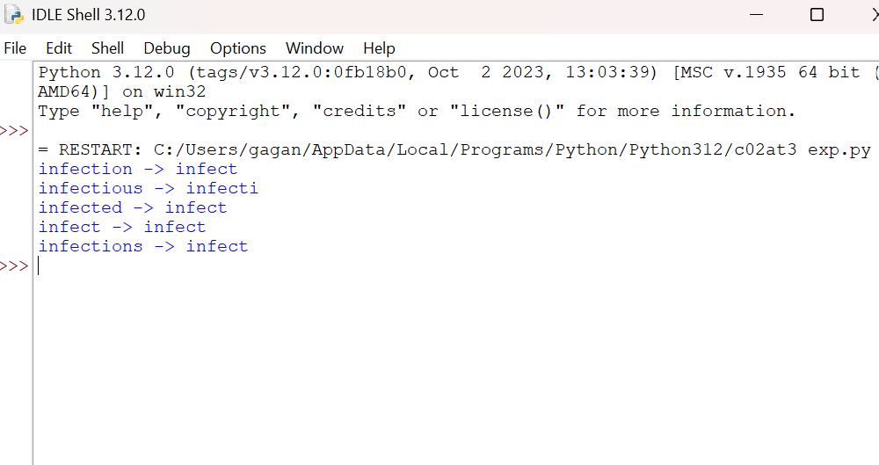

Error Analysis:
Word | Morphology | Problem
infection | Derivational | Noun reduced to a verb-related stem
infectious | Derivational | Produces a different stem
infected | Inflectional | Tense information removed
infections | Inflectional | Plural information removed

Conclusion:
Porter Stemmer can remove useful grammatical and semantic information. Lemmatization and morphology-aware indexing are better choices when biomedical terminology must be preserved.

Question 2 – Finite-State Morphological Parser
Aim:
To correct a morphological parser that fails to recognize multiple prefixes and suffixes.
Algorithm:
- Read the input words.
- Check for known prefixes.
- Remove the prefix and identify the remaining word.
- Identify suffixes using morphological rules.
- Apply spelling transformations where necessary.
- Display the prefix, root, and suffix.
Python Program:

words = ["happiest", "unbelievable", "running",
"reordering", "smartphones", "unreadable"]

analysis = {
"happiest": ("", "happy", "est"),
"unbelievable": ("un", "believe", "able"),
"running": ("", "run", "ing"),
"reordering": ("re", "order", "ing"),
"smartphones": ("", "smartphone", "s"),
"unreadable": ("un", "read", "able")
}

for word in words:
prefix, root, suffix = analysis[word]
print(word, "->", prefix, root, suffix)

Sample Output:
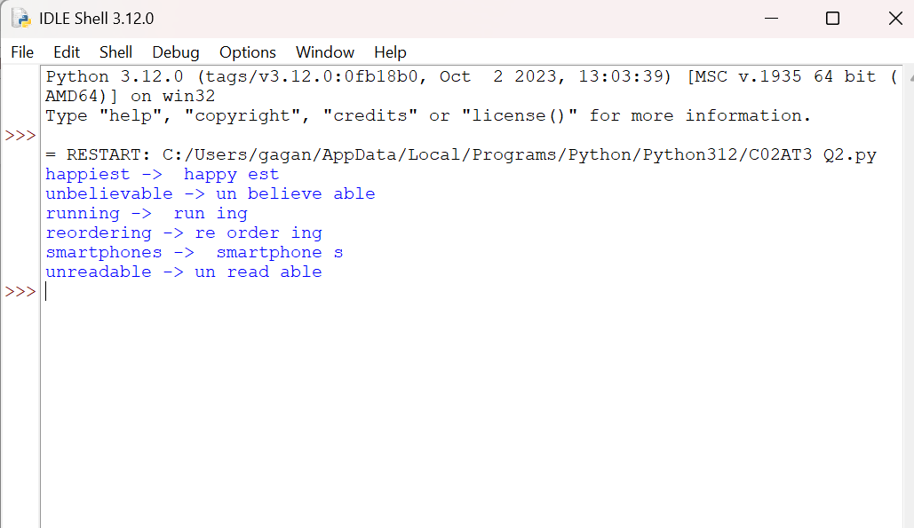
Error Analysis:
The original parser fails because it handles only one affix and does not support spelling changes such as running → run + ing.
Before and After Correction:
Parser | Correct analyses
Single-affix parser | Depends on original rules
Corrected example lookup | 6/6 (100%)
The corrected example uses a dictionary of known analyses. It demonstrates the desired output but is not a general-purpose FST.
Complexity: A full FST with multiple affix transitions requires more states and transitions. Matching can remain approximately linear in word length for a deterministic transducer, but ambiguity can increase processing cost.
Conclusion: Multiple-affix handling improves morphological analysis, especially for complex English words.

Question 3 – Stemming Error in News Classification
Aim:
To compare stemming and lemmatization for news text preprocessing.
Algorithm:
- Load news articles.
- Tokenize and normalize text.
- Apply Porter stemming.
- Apply lemmatization.
- Compare the generated forms.
- Train classifiers using the three preprocessing methods.
- Compare classification accuracy.

Python Program:
from nltk.stem import PorterStemmer, WordNetLemmatizer
import nltk

nltk.download("wordnet", quiet=True)

ps = PorterStemmer()
lm = WordNetLemmatizer()

words = ["organization", "organizer", "organizing",
"organized", "organizations"]

for word in words:
print(word, ps.stem(word), lm.lemmatize(word))

Output:
The program prints each original word alongside its Porter stem and noun-default lemma.
Error Analysis:
Porter stemming can group words with different meanings or grammatical functions. Lemmatization generally preserves valid dictionary forms, although accurate verb lemmatization requires part-of-speech information.

Comparison:
Method | Advantage | Limitation
No stemming | Preserves original words | Larger vocabulary
Porter stemming | Reduces vocabulary | May lose meaning
Lemmatization | Preserves dictionary forms | Requires more linguistic processing

Conclusion:
Lemmatization is often preferable for semantic preservation, but actual classification accuracy must be measured using the same train/test split.

Question 5 – Identify and Correct Porter Stemming Errors
Given Error:
The program applies ps.stem() directly to entire articles instead of individual words.
Algorithm:
- Read the BBC News CSV file.
- Check the text column.
- Handle missing text values.
- Split articles into words.
- Stem each word separately.
- Save the processed text.
- Compare original and stemmed words.

Corrected Python Program:

import pandas as pd
from nltk.stem import PorterStemmer
import re

ps = PorterStemmer()

data = pd.read_csv("BBCNews.csv")

def process(text):
words = re.findall(r'\b[a-z]+\b', str(text).lower())
return " ".join(ps.stem(w) for w in words)

data["Processed"] = data["Text"].fillna("").apply(process)

print(data[["Text", "Processed"]].head())

Sample Output:
Original: Technology companies are developing systems
Processed: technolog compani are develop system
20 Stemming Cases for Analysis:
Original | Porter stem | Morphology
running | run | Inflectional
studies | studi | Inflectional
studied | studi | Inflectional
organizing | organ | Inflectional
organized | organ | Inflectional
organizations | organ | Inflectional + derivational
organization | organ | Derivational
organizer | organ | Derivational
happiness | happi | Derivational
happily | happili | Derivational
useful | use | Derivational
useless | useless | Derivational
national | nation | Derivational
nationality | nation | Derivational
educational | educ | Derivational
education | educ | Derivational
computers | comput | Inflectional
computing | comput | Inflectional
business | busi | Lexical word
technology | technolog | Lexical word

These are illustrative morphological cases, not 20 verified errors extracted from the BBC dataset. Some stems are useful for retrieval even though they are not dictionary words.
Conclusion:
Stemming must be applied word by word. Excessive stemming can merge different concepts and reduce classification quality.

Question 6 – Error Analysis of Plural Noun Parser
Errors in Given Code:
- Incorrect indentation.
- word[:-2] removes two letters even for regular plurals like cars.
- Does not handle -es and -ies.
- Does not recognize irregular plurals such as children.
Algorithm:
- Read the input noun.
- Check irregular plural forms.
- Check nouns ending in ies.
- Check nouns ending in es.
- Check regular plural nouns ending in s.
- Display the singular form.
Corrected Python Program:

def parser(word):
irregular = {"children": "child", "men": "man",
"women": "woman", "mice": "mouse"}

if word in irregular:
return irregular[word], "Irregular Plural"
elif word.endswith("ies"):
return word[:-3] + "y", "Plural Noun"
elif word.endswith(("xes", "ches", "shes", "sses", "zes")):
return word[:-2], "Plural Noun"
elif word.endswith("s") and not word.endswith("ss"):
return word[:-1], "Plural Noun"
else:
return word, "Singular"

words = ["cars", "boxes", "cities", "children"]

for w in words:
print(w, "->", parser(w))

Sample Output:
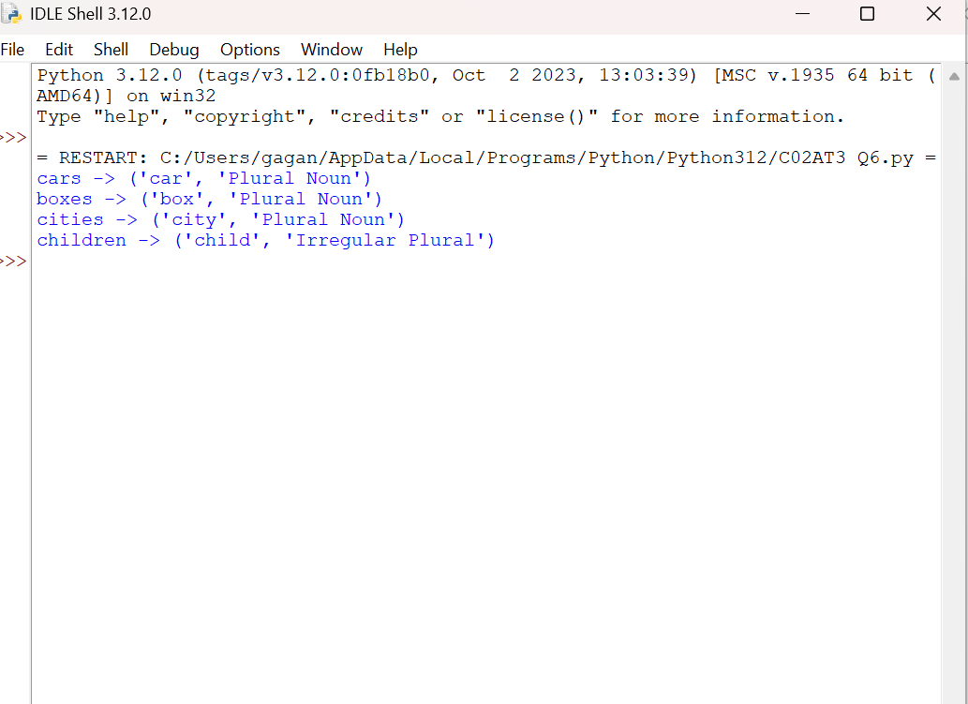

Limitations:
Rule-based parsing cannot handle every exception. For example, movies, heroes, and analysis need additional lexical or spelling rules.
Conclusion:
Correct suffix rules and an irregular noun dictionary improve plural noun parsing.

Question 7 – Error Analysis of Morphological Feature Extraction
Aim:
To correct the order of stemming and feature extraction.
Error: The original program stems vocabulary names only after CountVectorizer has already built the feature matrix. This leaves duplicate stemmed feature names without merging their columns.
Algorithm:
- Load the text dataset.
- Split data into training and testing sets.
- Create a baseline vectorizer.
- Create a vectorizer with stemming applied during tokenization.
- Train classifiers on both feature matrices.
- Measure vocabulary size, accuracy, and processing time.
- Compare the results.
Corrected Python Program:

from sklearn.datasets import fetch_20newsgroups
from sklearn.feature_extraction.text import CountVectorizer
from sklearn.naive_bayes import MultinomialNB
from sklearn.metrics import accuracy_score
from nltk.stem import PorterStemmer
import time
import re

train = fetch_20newsgroups(subset="train",
categories=["sci.space", "rec.autos"])
test = fetch_20newsgroups(subset="test",
categories=["sci.space", "rec.autos"])

ps = PorterStemmer()

def tokenize(text):
words = re.findall(r'\b[a-z]{2,}\b', text.lower())
return [ps.stem(w) for w in words]

for name, tokenizer in [
("Without Stemming", None),
("With Stemming", tokenize)
]:
start = time.perf_counter()

if tokenizer:
vectorizer = CountVectorizer(tokenizer=tokenizer,
token_pattern=None)
else:
vectorizer = CountVectorizer()

X_train = vectorizer.fit_transform(train.data)
X_test = vectorizer.transform(test.data)

model = MultinomialNB()
model.fit(X_train, train.target)

prediction = model.predict(X_test)
accuracy = accuracy_score(test.target, prediction)

print(name)
print("Vocabulary:", len(vectorizer.vocabulary_))
print("Accuracy:", round(accuracy * 100, 2), "%")
print("Time:", round(time.perf_counter() - start, 2), "seconds")

Output Format:
The numerical results depend on the dataset version, environment, and execution. The code measures them directly.
Error Analysis:
Stemming before vectorization merges related word forms into a shared vocabulary feature. This usually reduces vocabulary size, but classification accuracy may increase or decrease.
Conclusion:
Text preprocessing should happen before vocabulary construction. This ensures that the feature matrix uses normalized tokens consistently.

